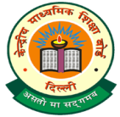
DELHI WORLD PUBLIC SCHOOL, RAIGARH (CHHATTISGARH) 496001
Under the aegis of the Delhi World Foundation, New Delhi CBSE Affiliation No :- 3330424
Bade Rampur, Raigarh Phone: - 9691825746/47 Website:- dwpsraigarh.com E-Mail - dwps.raigarh@gmail.com

Assessment Policy

DWPS/PC/2021-22/01 (CLASSES – Nursery & KG) Date: - 23 March 2021
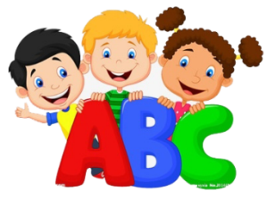

Dear Parent
Greetings!

As we all know the early years are the most significant years for the human growth, development and learning, so we, at Delhi World Public School, are ensuring that our curriculum is holistic, developmentally appropriate and most importantly play and activity based. The curriculum aims at providing a cohesive approach to facilitate the unfolding of each child’s innate potential in all the domains of development. The different domains are
- Physical well-being, health and motor development
- Personal, social and emotional development
- Creative and aesthetic development
- Language, communication and literacy development
- Cognitive development: environmental awareness, development of scientific temper and developing mathematical thinking and reasoning

Our module for assessing the performance of learners of Nursery and KG under different domains will be by awarding grades during the entire academic year. Assessment will be carried out using multiple modes such as Anecdotal Records, samples of children’s work, worksheets, oral work, observation, participation in various activities and interaction with peer group.

No marks and ranks will be awarded nor reflected in the assessment report card of your ward at the time of promotion to the next higher class. Therefore, it is earnestly suggested that your wards performance may please be viewed in terms of grades only. However, the levels of performance indicated by different grades will be as follows:-
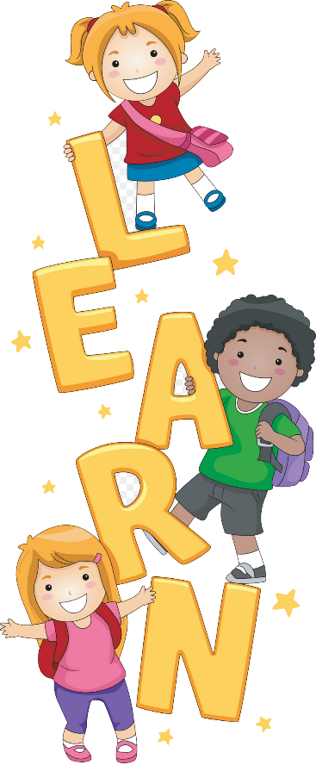
A+ Outstanding (Exceeds the expectations of the standard)
A Excellent (Meets the expectations of the standard)
B Very good (Approaches the expectations of the standard)
C Good (Developing prerequisites for the standard)
D Average (Needs encouragement)

“I am just a child, take it easy. I am still learning.”

Shweta Singh
Principal

